SUBMITTED BY:

RATHI R

Reg.no:961819106044

ECE,4 th year

Ponjesly college of

Engineering

B12-6A2E

CODE:

import random

for i in range(0,20):

temp=random.randint(30,100)

hum=random.randint(60,100)

if temp > 80 and hum < 90 :

print("HIGH TEMPERATURE ",temp)

elif hum > 90 and temp > 80 :

print("HAZARD DETECTED WITH TEMPERATURE : %i AND HUMIDITY : %i" %(temp,hum))

elif hum >90 and temp <80 :

print("HIGH HUMIDITY : ",hum)

else:

print("ALL GOOD")

INPUT:

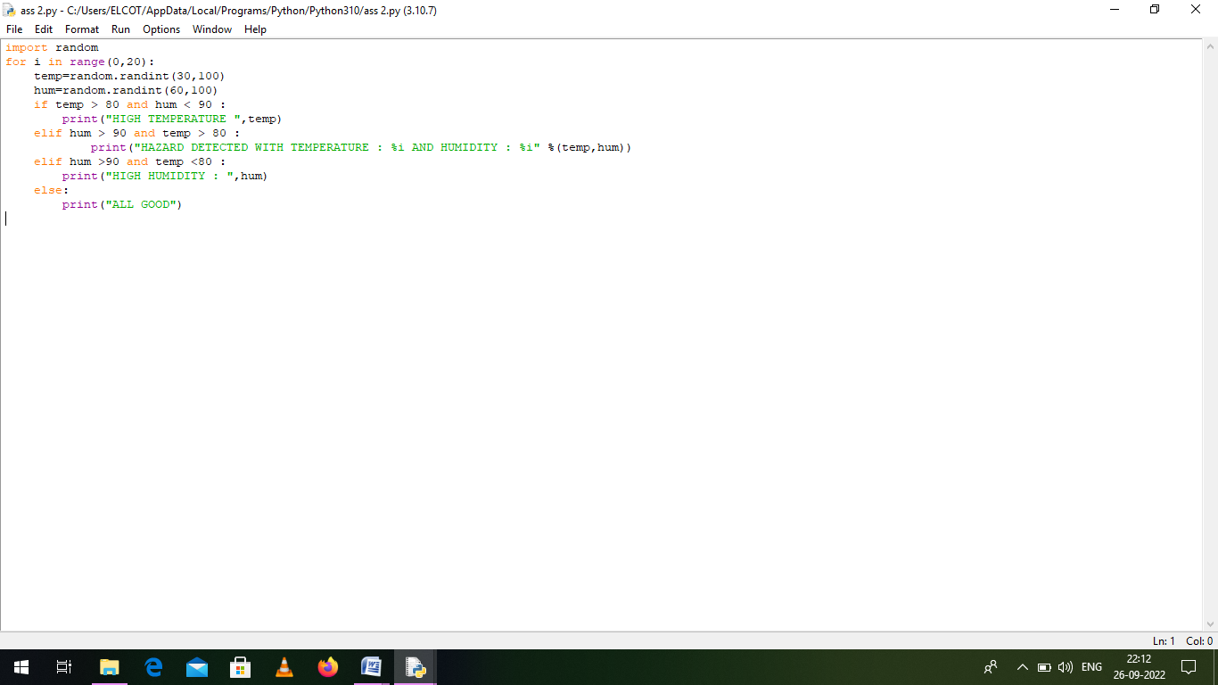

OUTPUT: 